AP-Functional Programming

# Week1- Caesar

Assignment: Code Caesar’s Cypher for a string of characters.

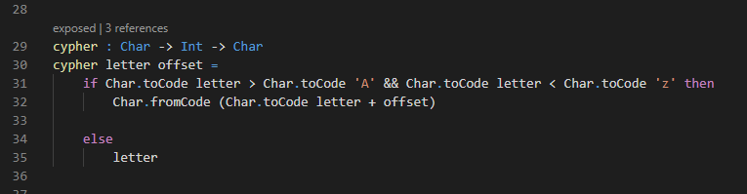

Main code that does the cypher. Takes the character as input and an offset amount and outputs the corresponding letter.

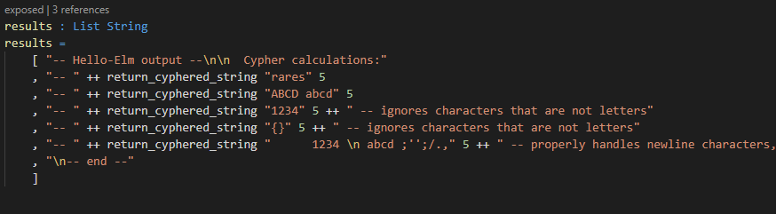

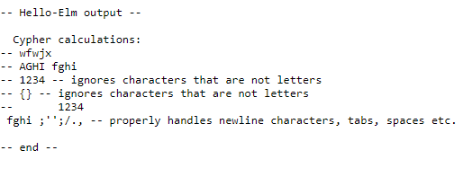

Test cases with output: Testing that only letters are getting cyphered. Also testing against newline and other special characters.

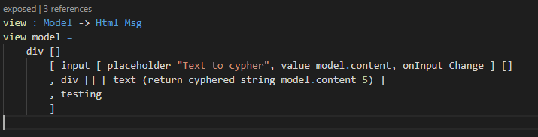

Also implemented a module that runs the cypher in real time on text using an html input in the browser.

